**Ancient Chinese Medicine**

Mohammed Arif Mainuddin  
ID: 2211577042

Course: HIS102.4   
Assignment: Ancient Chinese Medicine

Submitted to: Dr. Faruk Shah (Fkh)   
Date: 09/01/2024

# **Abstract**

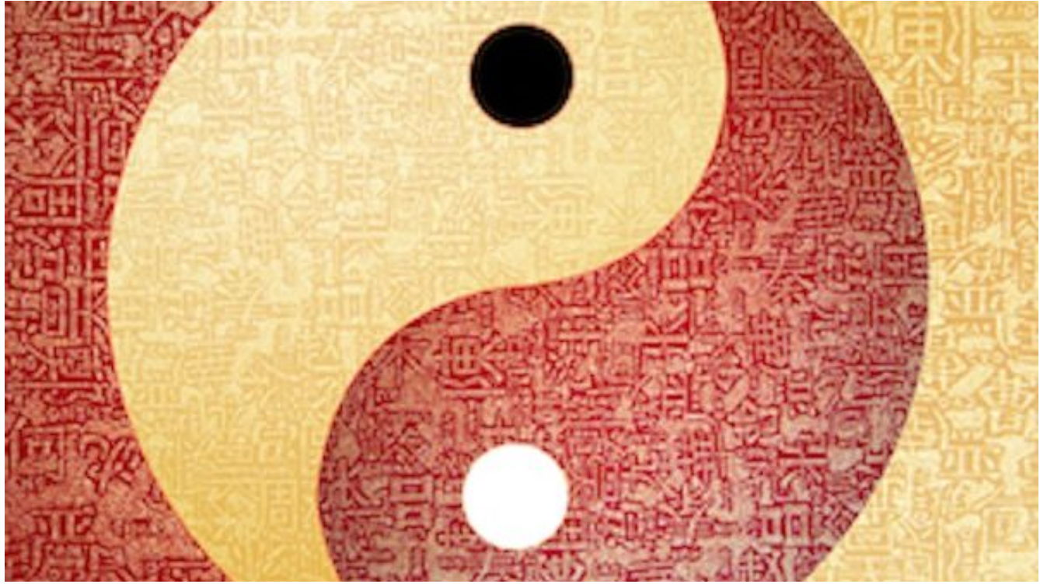As one of the major contemporary alternative medicines, ancient or traditional Chinese medicine (TCM) continues its influence in Chinese communities and has begun to attract the academic attention in the world of modern medicine. This paper aims to summarize about the ancient Chinese Medicine. This paper focuses the development of the ancient Chinese Medicine, its health concept, strategy and methods and also future perspective of ancient or traditional Chinses Medicine (TCM).

Figure 1 Ancient Chinese Medicine

**Table of Contents**

**Abstract** 2

**Table of Figures** 4

***Definition of Ancient Chinese Medicine*** 5

***Development of Ancient Chinese Medicine*** 6

***Health Concept in Ancient Chinese Medicine*** 7

***Strategy and Methods in Ancient Chinese Medicine*** 8

***Future Perspective of Ancient Chinese Medicine*** 9

***Conclusion*** 9

***References*** 10

# 

# **Table of Figures**

1. Figure 1 Ancient Chinese Medicine ----------------------------------------- 2
2. Figure 2 Yin and Yang --------------------------------------------------------- 5
3. Figure 3 Interconnection of mind-body-nature ----------------------------- 7
4. Figure 4 Acupuncture ---------------------------------------------------------- 8

# **Definition of Ancient Chinese Medicine**

Ancient or Traditional Chinese Medicine (TCM) is a medical knowledge system discovered by the ancient Chinese people. This treatment is maintain harmony between man and nature. It’s a holistic approach. It’s a combinational treatment of Yin (passive and negative force) and Yang (active and positive force), (Figure 2). TCM considers the interconnectedness of mind, body, and nature to promote overall well-being prevent illness. TCM practices includes acupuncture, herbal medicine, moxibustion, Tunia massage and many others natural treatment to support health in a balanced way. This treatment doesn’t imply any chemical medicine or any kind of ray. Since this treatment doesn’t imply any kind of modern chemical or ray treatment, this treatment doesn’t have any kind of side effect. In Chinese community, this treatment has been influencing many generation.

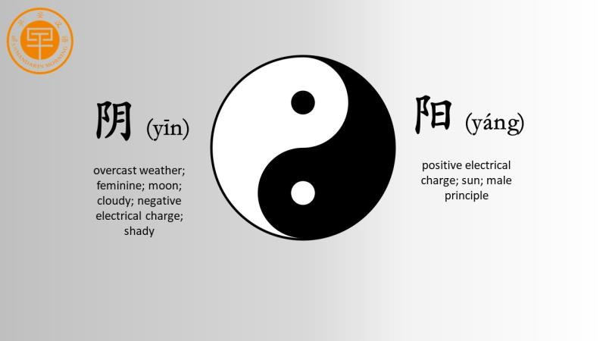

Figure 2: Yin and Yang

# 

# **Development of Ancient Chinese Medicine**

Chinese medicine has a 3000-year history, tracing back to the Yin and Shang dynasties. Oracle inscriptions in the Yin Dynasty documented over 20 diseases. In the Zhou Dynasty, doctors were categorized, and the Spring and Autumn Period marked the separation of medicine and witchcraft, giving rise to the yin-yang and five elements theory. The Yellow Emperor's Canon of Medicine became a fundamental guide, influencing theoretical research and clinical practices. The Qin and Han dynasties saw the clarification of medical concepts in texts like The Classic of Difficult Issues. Pulse diagnosis, acupuncture, and moxibustion gained prominence during the Han Dynasty. Medical education involved familial or apprentice inheritance, evolving into a system with imperial medical academies in subsequent dynasties. The Sui and Tang dynasties witnessed advancements in clinical departments, notably in traumatology, obstetrics, pediatrics, and ophthalmology. Sun Simiao's contributions in the Tang Dynasty emphasized maternal and child health care and diet therapy. Tang Dynasty also laid the foundation for materia medica, later refined in the Song and Ming dynasties. Notable historical events include Jianzhen's travels to Japan in the Tang Dynasty, spreading Chinese medicine influence, and medical exchanges between China and Southeast Asian countries during various dynasties. This historical narrative significantly influences Traditional Chinese Medicine (TCM) practices today.

# ***Health Concept in Ancient Chinese Medicine***

Ancient Chinese Medicine revolves around the concept of maintaining balance for optimal health. The key idea is Qi, a special energy that flows through the body in-specific paths. Good health is achieved when Qi flows smoothly, but disruptions or imbalances, like Yin and Yang (opposite forces) getting out of sync, can lead to illness. To restore balance, ancient Chinese practitioners use acupuncture, involving tiny needles, and prescribe special herbs. Additionally, exercises like Tai Chi are recommended to promote overall well-being. Prevention is a cornerstone of this approach, emphasizing the importance of lifestyle choices, diet, and emotional well-being. In this holistic tradition, the focus extends beyond merely fixing what's wrong; it's about proactively maintaining harmony. Eating right, leading a balanced life, and tending to emotional health are seen as crucial for preventing issues before they arise. Ancient Chinese Medicine aligns with the Daoist philosophy, recognizing the interconnectedness of the body, mind, and spirit (Figure 3). By living in harmony with nature and understanding the cyclical nature of life, individuals can achieve lasting health and well-being.

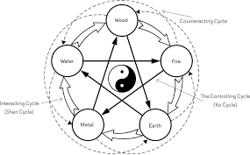

Figure 3: Interconnection of mind-body-nature

# ***Strategy and Methods in Ancient Chinese Medicine***

Ancient Chinese Medicine (ACM) is deeply rooted in strategic principles and methods aimed at maintaining and restoring the balance of vital energy, or Qi, within the body. The foundational concept is based on the interplay of Yin and Yang forces, which represent opposing yet complementary aspects of life. Understanding the dynamics between these forces guides practitioners in formulating effective strategies to promote health. One primary method in ACM is acupuncture (Figure 4), a technique involving the insertion of thin needles into specific points along the body's meridians to regulate the flow of Qi. The strategic placement of these needles is crucial, targeting areas where the energy balance may be disrupted. This method is akin to a strategic intervention, redirecting the flow of energy to restore equilibrium. Herbal medicine is another integral component of ACM strategy. Various herbs are carefully selected and combined to create formulas tailored to address specific imbalances in the body. The choice of herbs and their proportions reflects a nuanced understanding of the body's intricate energy dynamics. Practitioners employ a strategic approach in crafting these herbal combinations to optimize therapeutic effects. Ancient Chinese Medicine also emphasizes the importance of preventive strategies. Diet plays a crucial role in maintaining health, and ACM prescribes specific foods based on their energetic qualities to support the body's balance. By strategically incorporating certain foods into one's diet, individuals can proactively promote well-being and prevent imbalances from arising. In addition to acupuncture, herbal remedies, and dietary considerations, movement-based practices like Tai Chi and Qigong are employed as strategic methods in ACM. These exercises are designed to enhance the flow of Qi, promoting overall balance and vitality. The slow, deliberate movements of Tai Chi, for example, engage both the body and mind in a coordinated manner, aligning with the strategic objective of harmonizing energy.

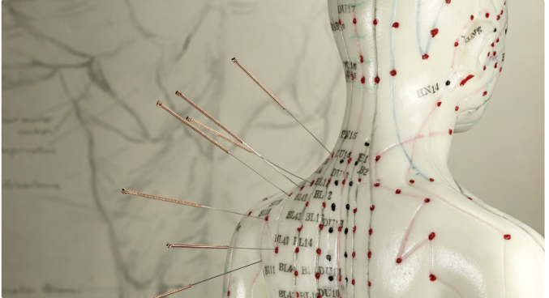

Figure 4: Acupuncture

Figure 5: Ancient Chinese MedicineFigure 6: Acupuncture

Figure 7: Ancient Chinese Medicine

Figure 8: Ancient Chinese MedicineFigure 9: Acupuncture

Figure 10: Ancient Chinese MedicineFigure 11: Acupuncture

Figure 12: Ancient Chinese Medicine

Figure 13: Ancient Chinese Medicine

Figure 14: Ancient Chinese Medicine

Figure 15: Ancient Chinese MedicineFigure 16: Acupuncture

Figure 17: Ancient Chinese MedicineFigure 18: Acupuncture

Figure 19: Ancient Chinese Medicine

Figure 20: Ancient Chinese MedicineFigure 21: Acupuncture

Figure 22: Ancient Chinese MedicineFigure 23: Acupuncture

Figure 24: Ancient Chinese Medicine

Figure 25: Ancient Chinese Medicine

Figure 26: Ancient Chinese Medicine

Figure 27: Ancient Chinese Medicine

Figure 28: Ancient Chinese Medicine

Figure 29: Ancient Chinese Medicine

Figure 30: Ancient Chinese Medicine

Figure 31: Ancient Chinese MedicineFigure 32: Acupuncture

Figure 33: Ancient Chinese MedicineFigure 34: Acupuncture

Figure 35: Ancient Chinese Medicine

Figure 36: Ancient Chinese MedicineFigure 37: Acupuncture

Figure 38: Ancient Chinese MedicineFigure 39: Acupuncture

Figure 40: Ancient Chinese Medicine

Figure 41: Ancient Chinese Medicine

Figure 42: Ancient Chinese Medicine

Figure 43: Ancient Chinese MedicineFigure 44: Acupuncture

Figure 45: Ancient Chinese MedicineFigure 46: Acupuncture

Figure 47: Ancient Chinese Medicine

Figure 48: Ancient Chinese MedicineFigure 49: Acupuncture

Figure 50: Ancient Chinese MedicineFigure 51: Acupuncture

Figure 52: Ancient Chinese Medicine

Figure 53: Ancient Chinese Medicine

Figure 54: Ancient Chinese Medicine

Figure 55: Ancient Chinese Medicine

Figure 56: Ancient Chinese Medicine

Figure 57: Ancient Chinese Medicine

Figure 58: Ancient Chinese Medicine

Figure 59: Ancient Chinese Medicine

Figure 60: Ancient Chinese Medicine

Figure 61: Ancient Chinese Medicine

Figure 62: Ancient Chinese Medicine

Figure 63: Ancient Chinese Medicine

Figure 64: Ancient Chinese Medicine

Figure 65: Ancient Chinese Medicine

Figure 66: Ancient Chinese Medicine

Figure 67: Ancient Chinese MedicineFigure 68: Acupuncture

Figure 69: Ancient Chinese MedicineFigure 70: Acupuncture

Figure 71: Ancient Chinese Medicine

Figure 72: Ancient Chinese MedicineFigure 73: Acupuncture

Figure 74: Ancient Chinese MedicineFigure 75: Acupuncture

Figure 76: Ancient Chinese Medicine

Figure 77: Ancient Chinese Medicine

Figure 78: Ancient Chinese Medicine

Figure 79: Ancient Chinese MedicineFigure 80: Acupuncture

Figure 81: Ancient Chinese MedicineFigure 82: Acupuncture

Figure 83: Ancient Chinese Medicine

Figure 84: Ancient Chinese MedicineFigure 85: Acupuncture

Figure 86: Ancient Chinese MedicineFigure 87: Acupuncture

Figure 88: Ancient Chinese Medicine

Figure 89: Ancient Chinese Medicine

Figure 90: Ancient Chinese Medicine

Figure 91: Ancient Chinese Medicine

Figure 92: Ancient Chinese Medicine

Figure 93: Ancient Chinese Medicine

Figure 94: Ancient Chinese Medicine

Figure 95: Ancient Chinese MedicineFigure 96: Acupuncture

Figure 97: Ancient Chinese MedicineFigure 98: Acupuncture

Figure 99: Ancient Chinese Medicine

Figure 100: Ancient Chinese MedicineFigure 101: Acupuncture

Figure 102: Ancient Chinese MedicineFigure 103: Acupuncture

Figure 104: Ancient Chinese Medicine

Figure 105: Ancient Chinese Medicine

Figure 106: Ancient Chinese Medicine

Figure 107: Ancient Chinese MedicineFigure 108: Acupuncture

Figure 109: Ancient Chinese MedicineFigure 110: Acupuncture

Figure 111: Ancient Chinese Medicine

Figure 112: Ancient Chinese MedicineFigure 113: Acupuncture

Figure 114: Ancient Chinese MedicineFigure 115: Acupuncture

Figure 116: Acupuncture

Figure 117: Ancient Chinese MedicineFigure 118: Acupuncture

Figure 119: Ancient Chinese Medicine

Figure 120: Ancient Chinese MedicineFigure 121: Acupuncture

Figure 122: Ancient Chinese MedicineFigure 123: Acupuncture

Figure 124: Ancient Chinese Medicine

Figure 125: Ancient Chinese Medicine

Figure 126: Ancient Chinese Medicine

Figure 127: Ancient Chinese MedicineFigure 128: Acupuncture

Figure 129: Ancient Chinese MedicineFigure 130: Acupuncture

Figure 131: Ancient Chinese Medicine

Figure 132: Ancient Chinese MedicineFigure 133: Acupuncture

Figure 134: Ancient Chinese MedicineFigure 135: Acupuncture

Figure 136: Ancient Chinese Medicine

Figure 137: Ancient Chinese Medicine

Figure 138: Ancient Chinese Medicine

Figure 139: Ancient Chinese Medicine

Figure 140: Ancient Chinese Medicine

Figure 141: Ancient Chinese Medicine

Figure 142: Ancient Chinese Medicine

Figure 143: Ancient Chinese MedicineFigure 144: Acupuncture

Figure 145: Ancient Chinese MedicineFigure 146: Acupuncture

Figure 147: Ancient Chinese Medicine

Figure 148: Ancient Chinese MedicineFigure 149: Acupuncture

Figure 150: Ancient Chinese MedicineFigure 151: Acupuncture

Figure 152: Ancient Chinese Medicine

Figure 153: Ancient Chinese Medicine

Figure 154: Ancient Chinese Medicine

Figure 155: Ancient Chinese MedicineFigure 156: Acupuncture

Figure 157: Ancient Chinese MedicineFigure 158: Acupuncture

Figure 159: Ancient Chinese Medicine

Figure 160: Ancient Chinese MedicineFigure 161: Acupuncture

Figure 162: Ancient Chinese MedicineFigure 163: Acupuncture

Figure 164: Ancient Chinese Medicine

Figure 165: Ancient Chinese Medicine

Figure 166: Ancient Chinese Medicine

Figure 167: Ancient Chinese Medicine

Figure 168: Ancient Chinese Medicine

Figure 169: Ancient Chinese Medicine

Figure 170: Ancient Chinese Medicine

Figure 171: Ancient Chinese Medicine

Figure 172: Ancient Chinese Medicine

Figure 173: Ancient Chinese Medicine

Figure 174: Ancient Chinese Medicine

Figure 175: Ancient Chinese Medicine

Figure 176: Ancient Chinese Medicine

Figure 177: Ancient Chinese Medicine

Figure 178: Ancient Chinese Medicine

Figure 179: Ancient Chinese MedicineFigure 180: Acupuncture

Figure 181: Ancient Chinese MedicineFigure 182: Acupuncture

Figure 183: Ancient Chinese Medicine

Figure 184: Ancient Chinese MedicineFigure 185: Acupuncture

Figure 186: Ancient Chinese MedicineFigure 187: Acupuncture

Figure 188: Ancient Chinese Medicine

Figure 189: Ancient Chinese Medicine

Figure 190: Ancient Chinese Medicine

Figure 191: Ancient Chinese MedicineFigure 192: Acupuncture

Figure 193: Ancient Chinese MedicineFigure 194: Acupuncture

Figure 195: Ancient Chinese Medicine

Figure 196: Ancient Chinese MedicineFigure 197: Acupuncture

Figure 198: Ancient Chinese MedicineFigure 199: Acupuncture

Figure 200: Ancient Chinese Medicine

Figure 201: Ancient Chinese Medicine

Figure 202: Ancient Chinese Medicine

Figure 203: Ancient Chinese Medicine

Figure 204: Ancient Chinese Medicine

Figure 205: Ancient Chinese Medicine

Figure 206: Ancient Chinese Medicine

Figure 207: Ancient Chinese MedicineFigure 208: Acupuncture

Figure 209: Ancient Chinese MedicineFigure 210: Acupuncture

Figure 211: Ancient Chinese Medicine

Figure 212: Ancient Chinese MedicineFigure 213: Acupuncture

Figure 214: Ancient Chinese MedicineFigure 215: Acupuncture

Figure 216: Ancient Chinese Medicine

Figure 217: Ancient Chinese Medicine

Figure 218: Ancient Chinese Medicine

Figure 219: Ancient Chinese MedicineFigure 220: Acupuncture

Figure 221: Ancient Chinese MedicineFigure 222: Acupuncture

Figure 223: Ancient Chinese Medicine

Figure 224: Ancient Chinese MedicineFigure 225: Acupuncture

Figure 226: Ancient Chinese MedicineFigure 227: Acupuncture

Figure 228: Acupuncture

Figure 229: Ancient Chinese MedicineFigure 230: Acupuncture

Figure 231: Ancient Chinese Medicine

Figure 232: Ancient Chinese MedicineFigure 233: Acupuncture

Figure 234: Ancient Chinese MedicineFigure 235: Acupuncture

Figure 236: Ancient Chinese Medicine

Figure 237: Ancient Chinese Medicine

Figure 238: Ancient Chinese Medicine

Figure 239: Ancient Chinese MedicineFigure 240: Acupuncture

Figure 241: Ancient Chinese MedicineFigure 242: Acupuncture

Figure 243: Ancient Chinese Medicine

Figure 244: Ancient Chinese MedicineFigure 245: Acupuncture

Figure 246: Ancient Chinese MedicineFigure 247: Acupuncture

Figure 248: Ancient Chinese Medicine

Figure 249: Ancient Chinese Medicine

Figure 250: Ancient Chinese Medicine

Figure 251: Ancient Chinese Medicine

Figure 252: Ancient Chinese Medicine

Figure 253: Ancient Chinese Medicine

Figure 254: Ancient Chinese Medicine

Figure 255: Ancient Chinese MedicineFigure 256: Acupuncture

Figure 257: Ancient Chinese MedicineFigure 258: Acupuncture

Figure 259: Ancient Chinese Medicine

Figure 260: Ancient Chinese MedicineFigure 261: Acupuncture

Figure 262: Ancient Chinese MedicineFigure 263: Acupuncture

Figure 264: Ancient Chinese Medicine

Figure 265: Ancient Chinese Medicine

Figure 266: Ancient Chinese Medicine

Figure 267: Ancient Chinese MedicineFigure 268: Acupuncture

Figure 269: Ancient Chinese MedicineFigure 270: Acupuncture

Figure 271: Ancient Chinese Medicine

Figure 272: Ancient Chinese MedicineFigure 273: Acupuncture

Figure 274: Ancient Chinese MedicineFigure 275: Acupuncture

Figure 276: Ancient Chinese Medicine

Figure 277: Ancient Chinese Medicine

Figure 278: Ancient Chinese Medicine

Figure 279: Ancient Chinese Medicine

Figure 280: Ancient Chinese Medicine

Figure 281: Ancient Chinese Medicine

Figure 282: Ancient Chinese Medicine

Figure 283: Ancient Chinese Medicine

Figure 284: Ancient Chinese Medicine

Figure 285: Ancient Chinese Medicine

Figure 286: Ancient Chinese Medicine

Figure 287: Ancient Chinese Medicine

Figure 288: Ancient Chinese Medicine

Figure 289: Ancient Chinese Medicine

Figure 290: Ancient Chinese Medicine

Figure 291: Ancient Chinese MedicineFigure 292: Acupuncture

Figure 293: Ancient Chinese MedicineFigure 294: Acupuncture

Figure 295: Ancient Chinese Medicine

Figure 296: Ancient Chinese MedicineFigure 297: Acupuncture

Figure 298: Ancient Chinese MedicineFigure 299: Acupuncture

Figure 300: Ancient Chinese Medicine

Figure 301: Ancient Chinese Medicine

Figure 302: Ancient Chinese Medicine

Figure 303: Ancient Chinese MedicineFigure 304: Acupuncture

Figure 305: Ancient Chinese MedicineFigure 306: Acupuncture

Figure 307: Ancient Chinese Medicine

Figure 308: Ancient Chinese MedicineFigure 309: Acupuncture

Figure 310: Ancient Chinese MedicineFigure 311: Acupuncture

Figure 312: Ancient Chinese Medicine

Figure 313: Ancient Chinese Medicine

Figure 314: Ancient Chinese Medicine

Figure 315: Ancient Chinese Medicine

Figure 316: Ancient Chinese Medicine

Figure 317: Ancient Chinese Medicine

Figure 318: Ancient Chinese Medicine

Figure 319: Ancient Chinese MedicineFigure 320: Acupuncture

Figure 321: Ancient Chinese MedicineFigure 322: Acupuncture

Figure 323: Ancient Chinese Medicine

Figure 324: Ancient Chinese MedicineFigure 325: Acupuncture

Figure 326: Ancient Chinese MedicineFigure 327: Acupuncture

Figure 328: Ancient Chinese Medicine

Figure 329: Ancient Chinese Medicine

Figure 330: Ancient Chinese Medicine

Figure 331: Ancient Chinese MedicineFigure 332: Acupuncture

Figure 333: Ancient Chinese MedicineFigure 334: Acupuncture

Figure 335: Ancient Chinese Medicine

Figure 336: Ancient Chinese MedicineFigure 337: Acupuncture

Figure 338: Ancient Chinese MedicineFigure 339: Acupuncture

Figure 340: Acupuncture

Figure 341: Ancient Chinese MedicineFigure 342: Acupuncture

Figure 343: Ancient Chinese Medicine

Figure 344: Ancient Chinese MedicineFigure 345: Acupuncture

Figure 346: Ancient Chinese MedicineFigure 347: Acupuncture

Figure 348: Ancient Chinese Medicine

Figure 349: Ancient Chinese Medicine

Figure 350: Ancient Chinese Medicine

Figure 351: Ancient Chinese MedicineFigure 352: Acupuncture

Figure 353: Ancient Chinese MedicineFigure 354: Acupuncture

Figure 355: Ancient Chinese Medicine

Figure 356: Ancient Chinese MedicineFigure 357: Acupuncture

Figure 358: Ancient Chinese MedicineFigure 359: Acupuncture

Figure 360: Ancient Chinese Medicine

Figure 361: Ancient Chinese Medicine

Figure 362: Ancient Chinese Medicine

Figure 363: Ancient Chinese Medicine

Figure 364: Ancient Chinese Medicine

Figure 365: Ancient Chinese Medicine

Figure 366: Ancient Chinese Medicine

Figure 367: Ancient Chinese MedicineFigure 368: Acupuncture

Figure 369: Ancient Chinese MedicineFigure 370: Acupuncture

Figure 371: Ancient Chinese Medicine

Figure 372: Ancient Chinese MedicineFigure 373: Acupuncture

Figure 374: Ancient Chinese MedicineFigure 375: Acupuncture

Figure 376: Ancient Chinese Medicine

Figure 377: Ancient Chinese Medicine

Figure 378: Ancient Chinese Medicine

Figure 379: Ancient Chinese MedicineFigure 380: Acupuncture

Figure 381: Ancient Chinese MedicineFigure 382: Acupuncture

Figure 383: Ancient Chinese Medicine

Figure 384: Ancient Chinese MedicineFigure 385: Acupuncture

Figure 386: Ancient Chinese MedicineFigure 387: Acupuncture

Figure 388: Ancient Chinese Medicine

Figure 389: Ancient Chinese Medicine

Figure 390: Ancient Chinese Medicine

Figure 391: Ancient Chinese Medicine

Figure 392: Ancient Chinese Medicine

Figure 393: Ancient Chinese Medicine

Figure 394: Ancient Chinese Medicine

Figure 395: Ancient Chinese Medicine

Figure 396: Ancient Chinese Medicine

Figure 397: Ancient Chinese Medicine

Figure 398: Ancient Chinese Medicine

Figure 399: Ancient Chinese Medicine

Figure 400: Ancient Chinese Medicine

Figure 401: Ancient Chinese Medicine

Figure 402: Ancient Chinese Medicine

Figure 403: Ancient Chinese MedicineFigure 404: Acupuncture

Figure 405: Ancient Chinese MedicineFigure 406: Acupuncture

Figure 407: Ancient Chinese Medicine

Figure 408: Ancient Chinese MedicineFigure 409: Acupuncture

Figure 410: Ancient Chinese MedicineFigure 411: Acupuncture

Figure 412: Ancient Chinese Medicine

Figure 413: Ancient Chinese Medicine

Figure 414: Ancient Chinese Medicine

Figure 415: Ancient Chinese MedicineFigure 416: Acupuncture

Figure 417: Ancient Chinese MedicineFigure 418: Acupuncture

Figure 419: Ancient Chinese Medicine

Figure 420: Ancient Chinese MedicineFigure 421: Acupuncture

Figure 422: Ancient Chinese MedicineFigure 423: Acupuncture

Figure 424: Ancient Chinese Medicine

Figure 425: Ancient Chinese Medicine

Figure 426: Ancient Chinese Medicine

Figure 427: Ancient Chinese Medicine

Figure 428: Ancient Chinese Medicine

Figure 429: Ancient Chinese Medicine

Figure 430: Ancient Chinese Medicine

Figure 431: Ancient Chinese MedicineFigure 432: Acupuncture

Figure 433: Ancient Chinese MedicineFigure 434: Acupuncture

Figure 435: Ancient Chinese Medicine

Figure 436: Ancient Chinese MedicineFigure 437: Acupuncture

Figure 438: Ancient Chinese MedicineFigure 439: Acupuncture

Figure 440: Ancient Chinese Medicine

Figure 441: Ancient Chinese Medicine

Figure 442: Ancient Chinese Medicine

Figure 443: Ancient Chinese MedicineFigure 444: Acupuncture

Figure 445: Ancient Chinese MedicineFigure 446: Acupuncture

Figure 447: Ancient Chinese Medicine

Figure 448: Ancient Chinese MedicineFigure 449: Acupuncture

Figure 450: Ancient Chinese MedicineFigure 451: Acupuncture

# 

# ***Future Perspective of Ancient Chinese Medicine***

The future of Ancient Chinese Medicine (ACM) holds exciting possibilities as it continues to adapt and integrate with modern healthcare practices. Ongoing research is exploring the scientific basis of ACM principles, shedding light on its efficacy and expanding its application. As technology advances, innovative methods such as AI and machine learning may be employed to analyze large datasets and uncover patterns that validate ACM concepts. Collaborations between traditional ACM practitioners and Western medical professionals are on the rise, fostering a more comprehensive and integrated approach to patient care. This interdisciplinary collaboration may lead to the development of personalized medicine strategies that combine the strengths of both traditions. Innovations in herbal medicine are a focal point of ongoing research, with efforts to isolate and understand the active components of herbs. This may pave the way for the development of standardized herbal formulations and targeted therapies, enhancing the reproducibility and reliability of ACM treatments. The role of ACM in preventive healthcare is gaining recognition, aligning with the global shift towards holistic well-being. Integrative medicine centers are increasingly incorporating ACM practices to address not only specific ailments but also to promote overall health and wellness.

# ***Conclusion***

Ancient Chinese Medicine (ACM) is a long-lasting tradition that focuses on balance, harmony, and overall well-being. We discussed key ideas like Qi, Yin and Yang, and the methods used, such as acupuncture and herbal medicine. What's exciting is that ACM is still relevant today. Ongoing research and new ways of using ACM in collaboration with modern medicine show a promising future. Scientific studies and technology are proving that ACM methods work, making them a valuable addition to modern healthcare. ACM also has a lot to offer for chronic conditions, mental health, and overall wellness. It looks at the whole person – body, mind, and spirit. In the changing world of medicine, ACM brings a wise and holistic perspective, contributing to a healthcare system that cares for the person as a whole. Its enduring wisdom makes a lasting impact on how we understand and approach health.

# ***References***

1. Shuo Gu and Jianfeng Pei (2017). Innovating Chinese Herbal Medicine: From Traditional Health Practice to Scientific Drug Discovery. Frontiers in Pharmacology. doi: 10.3389/fphar.2017.00381
2. Reid D. (1996). The Shambhala Guide to Traditional Chinese Medicine. Boston, MA: Shambhala Publications.

[[Google Scholar](https://scholar.google.com/scholar_lookup?title=The+Shambhala+Guide+to+Traditional+Chinese+Medicine.&author=D.+Reid&publication_year=1996&)]

1. Wikipedia: Traditional Chinese medicine. Retrieved Jan 07, 2024, from [link](https://en.wikipedia.org/wiki/Traditional_Chinese_medicine)
2. The Johns Hopkins Universiy: Chinese Medicine. Retrieved Jan 07, 2024 from [link](https://www.hopkinsmedicine.org/health/wellness-and-prevention/chinese-medicine)
3. Catherine Caruso (2021). Exploring the Science of Acupuncture. Retrieved from [link](https://hms.harvard.edu/news/exploring-science-acupuncture)
4. A. White, E. Ernst (2004). A brief history of acupuncture. Retrieved from [link](https://academic.oup.com/rheumatology/article/43/5/662/1788282)